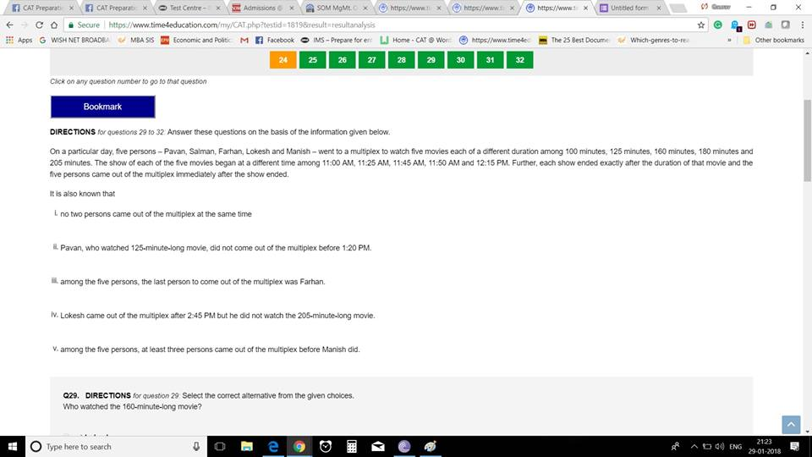

Q1. Who watched the 160 minute movie?

Q2. How many persons started watching a movie before manish did?

Q3. At what time did Lokesh come out of the multiplex?

Q4. What is the duration of the movie that began at 11:45? (In minutes)

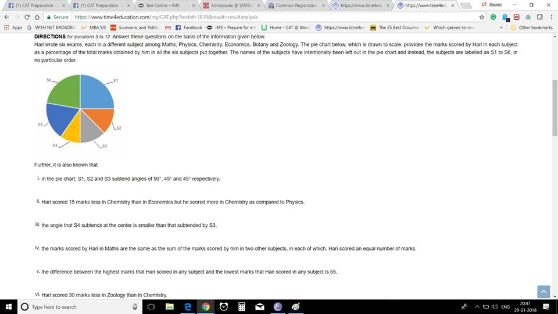

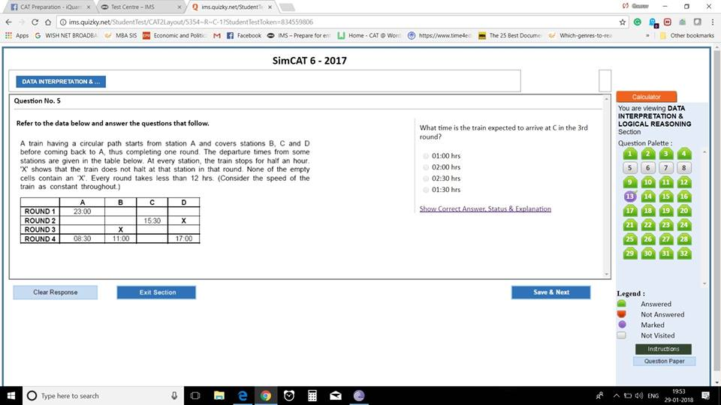

Q1. What time is the train expected to arrive at C in the 3rd round?  
A. 01:00   
B. 02:00  
C. 02.30  
D. 1.30

Q2. How much time is taken by the train to reach D after it starts from C?  
A. 3 HOURS  
B. 3 HOURS 30 MINUTES  
C. 2 HOUR 30 MINUTES  
D. 4 HOURS

 Q3. If the train begins round 1 on 21st January, when will it complete round 4? [TITA]

Q4. If all the halts at station B are reduced by 10 minutes and all the halts at station C are increased to 35 minutes, then at what time will the train complete round 3?   
A. 07:45  
B. 05:25  
C. 07:55  
D. 08:25

CAT 1995 question- Logic based DI again https://static.xx.fbcdn.net/images/emoji.php/v9/fd4/1/16/1f606.png😆

Four sisters-S,T,U,V are playing a game such that the loser doubles the money of each of the other players from her share. They played 4 games and each sister lost one game in alphabetic order. At the end of fourth game, each sister had Rs. 32.

Q1. How many rupees did S start with?  
Q2. Who started with the lowest amount?  
Q3. Who started with highest amount?  
Q4. What was the amount with U at the end of 2nd round?

IDEAL TIME-5 mins.

Backtracking is the key idea in such questions.

Top of Form

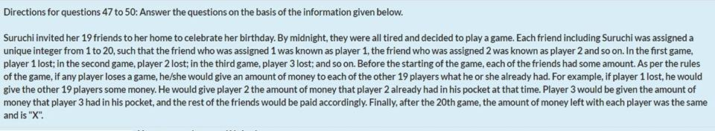

Well, the first code to crack in this problem is -   
If everyone's amount is doubled after each round and at the end everyone has same amount, then after second round, the amount with Player 1 and 2 should be same. After third round, amount with first 3 should be same, and so on.   
Secondly, you are talking about doubling at every step, i.e. the power of 2. So for basic calculation, you can assume that A was left with 2 after first round, which became 4,8,16... upto 2^20 after all rounds. Thus, the total amount of money is 20x2^20 and X is 2^20. This was all about analyzing the question. Actual problem solving starts here.  
After round 19, all 19 players had 2^19 and player 20 was responsible to make the amount 2^20, including his. Thus, amount with Player 20 after 19 round = total amount (which is 20\*2^20) minus the amount he gave to first 19 players each (which is 19\*2^19). Thus, he had 21\*2^19 amount after round 19. A basic observation: if he had this much amount after round 19, he should be having half of it after round 18, half of it in round 17 and so on. Thus, the initial amount of player 20 was 21.   
Similarly, After round 18, all 18 players had 2^18 and player 19 was responsible to make the amount 2^19, including his (not for player 20). Applying the same concept as above, you would notice that player 19 had 41 at the very beginning. Player 18 had 81, player 17 had 161 and so on.  
You can easily observe a pattern here. The initial amount present with player X was 2^(21-X)\*10 +1. Thus, player 4 had (2^17)\*10+1. This is equal to 5\*2^18+1 or (4\*1.25\*2^18)+1. Hence, 1.25X.

If everyone at the end has x  
Then total money with all of them=20x  
  
Now let initital money with player 4=m  
after R1=2\*m  
after R2=2^2\*m  
After R3=2^3\*m  
  
But after round 4=2^3m-(20x-2^3m)  
=2^4m-20x  
  
After R5=2\*(2^4m-20x)  
...  
After R20=2^16(2^4m-20x)=x  
  
So 16m-20x~0  
16m=20x  
m/x=20/16=5/4=1.25